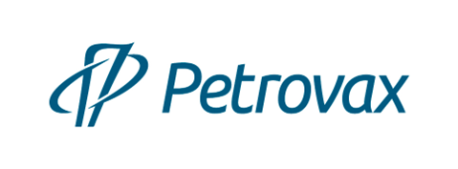
Petrovax Pharm is a Russian full-cycle biotechnological company with 25 years of successful experience.
The product portfolio includes its own original pharmaceutical products and vaccines, localized medicinal products, as well as generics and food supplements.
The company has its own research center and investment program for the R&D field, Petrovax holds patents for new molecules and pharmaceutical manufacturing technologies in Russia and abroad.
Petrovax’s manufacturing complex located in Moscow Region operates in full compliance with international GMP standards. The production capacity provides for manufacturing more than 160 million doses of immunobiological products per year.
Petrovax is the first Russian manufacturer of immunobiological products to pass international GMP certification from the state regulatory authorities of the EU and Iran.
Petrovax is the largest Russian exporter of pharmaceuticals and vaccines to EAEU, Middle East and EU countries. The geography of the company's supplies includes 12 countries.
Petrovax's partners are the world's leading pharmaceutical companies Pfizer, Abbott, Boehringer Ingelheim, ISU ABXIS.
In 2020-2021, Petrovax conducted large-scale studies of the vaccine and original medicines against COVID-19 in Russia and the EU.
The company's investment strategy is aimed at the investigation, development of production and import substitution of medicines and vaccines used in socially significant areas of medicine, such as oncological, autoimmune, infectious, and orphan diseases.
Petrovax has over 800 employees.
Our mission: Innovative products for treatment and better quality of life.

Contact Us:
NPO Petrovax Pharm, LLC
Phone: +7 (495) 730-75-45 e-mail: info@petrovax.ru, www.petrovax.ru

